Dofetilide (Tikosyn) Protocol
Prior to dofetilide initiation
- Review both current and previous admission medication and notify physician for contraindications per list below:
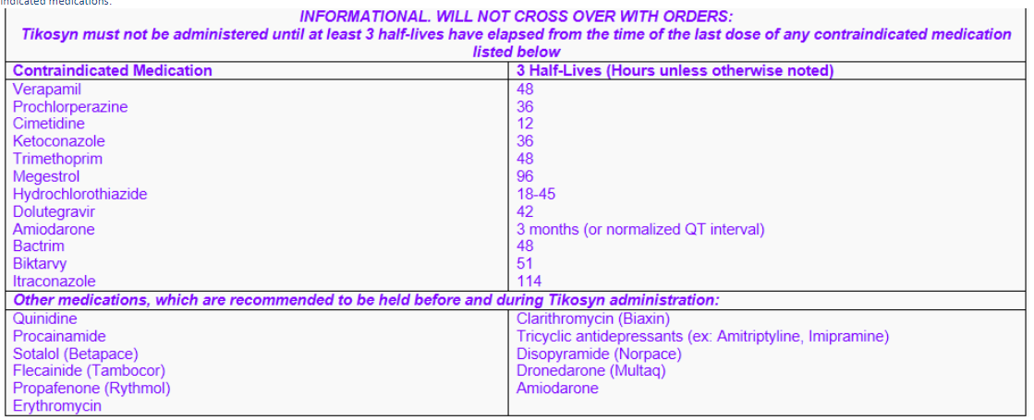

- Review anticoagulation – Confirm 4 weeks of compliance in patients taking dabigatran, rivaroxaban, apixaban, or warfarin (INR >/= 2). Notify physican if INR < 2 or non-compliant on other meds listed.

- Obtain CMP & Mg w/in 24 hours – Notify physician for hypomagnesemia (Mg++ <2.0) and/or hypokalemia (K+ <4.0)

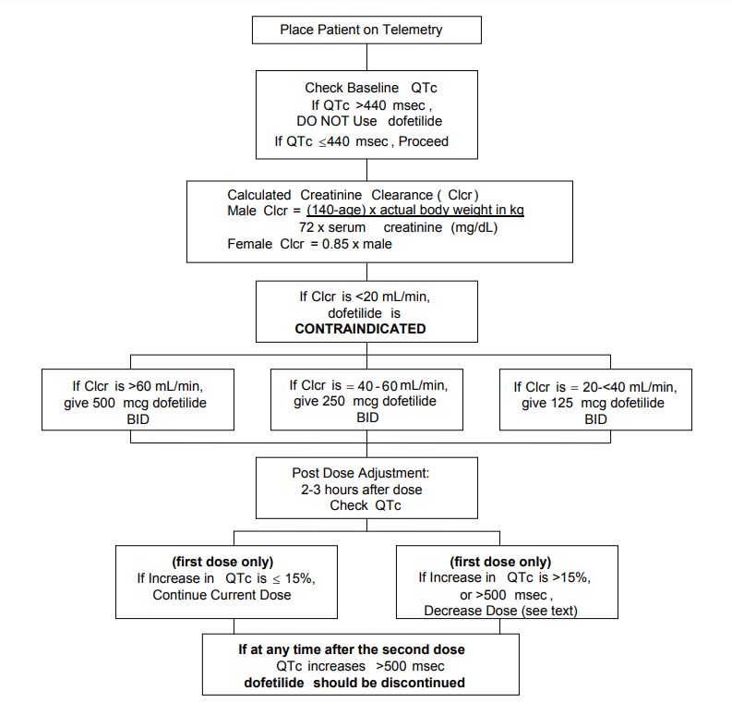
Dofetilide Initial Dosing Diagram
Dose Adjustments (1st dose only)
>15% increase in QTc from baseline or >500 msec or >550 msec in patients
with ventricular conduction abnormality
If starting dose is: | Adjusted dose is:
500mcg BID | 250mcg BID
250mcg BID | 125mcg BID
125mcg BID | 125mcg QD
Contact MD with:
- Baseline QTc
- Initial dofetilide dosing
(dosing may be adjusted based on medical condition)
- Dosing that is inconsistent with diagram and document in Sentri 7
- 15% increase in QTc/QT after initial dose per table:
Baseline QTc (msec) | >15% increase in QTc from baseline or >500 msec or >550 msec in patients with ventricular conduction abnormality
300 | 345
310 | 357
320 | 368
330 | 380
340 | 391
350 | 403
360 | 414
370 | 426
380 | 437
390 | 449
400 | 460
410 | 472
420 | 483
430 | 495
440 | 506
450 | 518
460 | 529
470 | 541
480 | 552
490 | 564
500 | 575

- QTc increase >500 msec or >550 msec in patients with BBB/ventricular abnormalities

